spring 4.3.10

<https://repo.spring.io/webapp/#/artifacts/browse/tree/General/libs-release-local/org/springframework/spring/4.3.10.RELEASE/spring-framework-4.3.10.RELEASE-dist.zip>

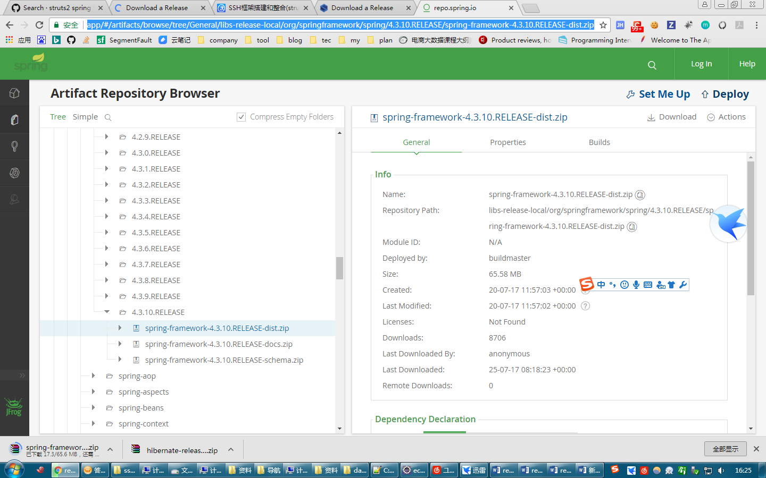

struts 2.5.12

<http://struts.apache.org/download.cgi#struts252>

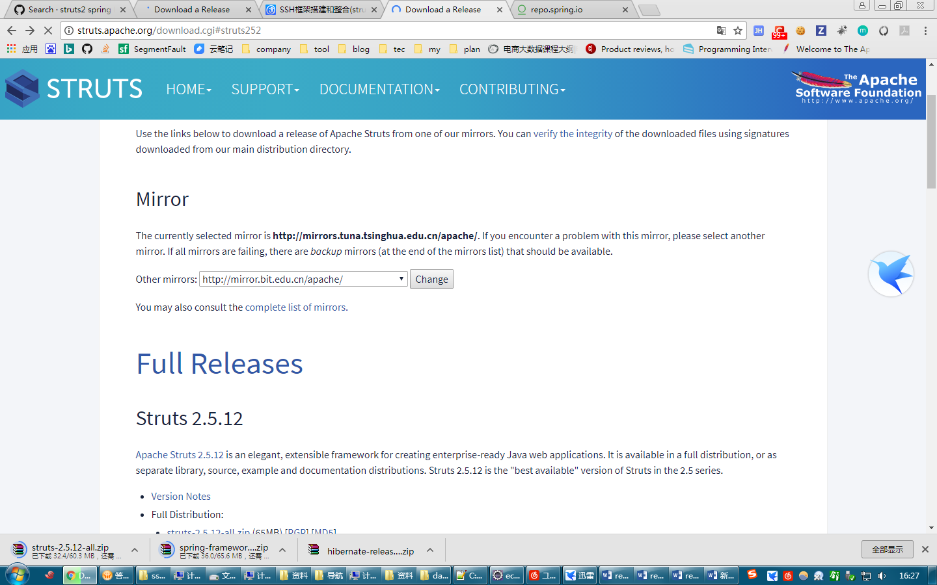

Hibernate 5.2.10

<http://hibernate.org/orm/>

